Lab 1.4.4.3 Researching IT and Networking Job Opportunities

Objectives

Research Job Opportunities

Background / Scenario

Jobs in Information Technology (IT) and computer networking continue to grow. Most employers require some form of industry standard certification, degree, or other qualifications from their potential employees, especially those with limited experience. The Cisco CCNA certification is a known and established entry-level networking certification that is respected in the industry. There are additional levels and kinds of Cisco certifications that one can attain, and each certification may enhance employment opportunities as well as salary range.

Research Job Opportunities

In this part, you will use a web browser to visit the popular job listing websites **monster.com**.

* 1. Open a web browser and go to a job listing website.

In the URL address bar type <http://monster.com> and press Enter.

**Note**: For job listings outside of the U.S., use the following link to search for your country:

<http://www.monster.com/geo/siteselection/>

* 1. Search for networking related jobs.
     1. Type the word ***Network Administrator*** in the job title box. Click **SEARCH** to continue.



* + 1. 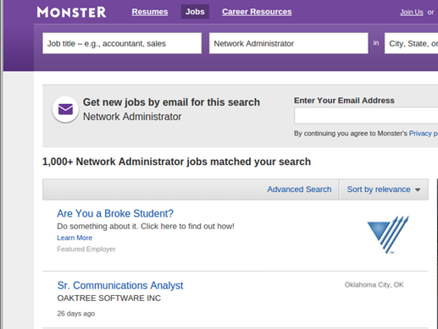Notice the search results:
    2. Now, focus your search by adding terms to the search for Network Administrator. Try terms like Cisco CCNA, CCNP, CCNA Security, CCNA Voice, etc.